Assignment 3 – Solving a Problem Using Open Data
1. Introduction: Problem Definition
Unemployment is one of the most important economic and social challenges faced by modern societies. High unemployment leads to income loss for households, increased poverty, and reduced tax revenues for governments. For Lithuania, unemployment trends are especially critical given the country’s relatively small labor market, demographic shifts, and emigration to other EU countries.
The problem addressed in this study is:
How has unemployment in Lithuania evolved over time, and what patterns can be identified using open data?
2. Dataset Identification and Description
Dataset title: Total Unemployment Rate (Labour Force Survey, age 15–74, % of active population)
Source: Eurostat – European Union Statistics Portal
Dataset code: tps00203
Portal link: https://ec.europa.eu/eurostat/databrowser/view/tps00203/default/table
API endpoint: https://ec.europa.eu/eurostat/api/dissemination/statistics/1.0/data/tps00203
Schema:
- time: Year of observation (annual frequency)
- geo: Country (Lithuania = LT)
- age: Age group (15–74 years)
- sex: Male, Female, or Total
- unit: Unit of measure (percentage of active population)
- value: Unemployment rate (%)
3. Data Cleaning and Processing
Steps taken:
1. Loaded the dataset using Python requests.
2. Decoded Eurostat’s compact JSON format.
3. Filtered for Lithuania (geo=LT, age=Y15-74, sex=T, unit=PC_ACT, freq=A).
4. Converted years to integers.
5. Sorted values chronologically.
4. Analytical Methods
The analysis was done using simple descriptive statistics:
- Trend analysis with a line chart (2013–2024).
- Yearly comparison of unemployment rates.
- Interpretation in relation to global events (financial crisis, COVID-19).
5. Results
Table 1: Lithuania unemployment rate (2013–2022)
Year | Unemployment Rate (%)
2013 | 11.8
2014 | 10.7
2015 | 9.1
2016 | 7.9
2017 | 7.1
2018 | 6.2
2019 | 6.3
2020 | 8.5
2021 | 7.1
2022 | 6.0
Figure 1: Unemployment Rate in Lithuania (2013–2024).
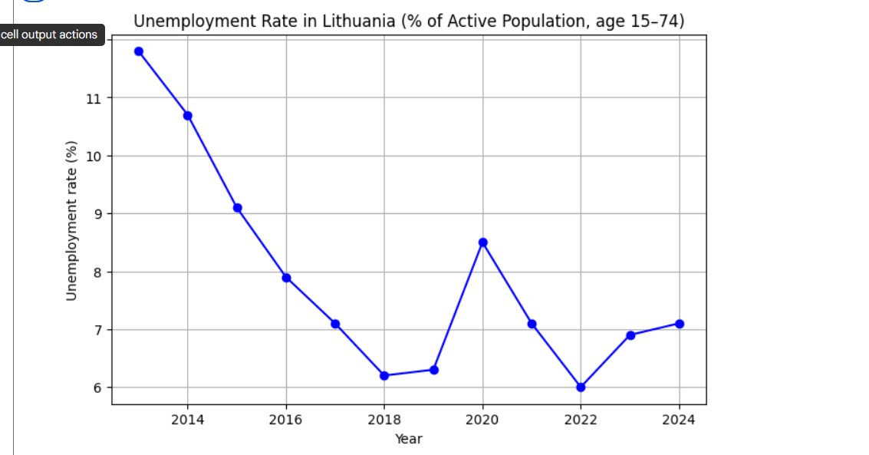
6. Discussion and Interpretation
The analysis shows that Lithuania’s unemployment rate has steadily declined since 2013, from 11.8% to around 6–7% in recent years. The data highlights:
- Post-crisis recovery after 2008–2009 financial crisis.
- A sharp rise in 2020 due to COVID-19.
- Stabilization around 6–7% in recent years.
7. Policy and Societal Implications
- Policymakers should strengthen unemployment insurance and training programs.
- Monitoring unemployment can serve as an early warning for recessions.
- Emigration and youth employment policies remain crucial.
8. Obstacles and Solutions
Obstacle: Eurostat JSON is not user-friendly and requires decoding.
Solution: Used Python to decode indexes into readable labels.
9. Licensing
Eurostat data is open under the Creative Commons Attribution (CC-BY 4.0) license.
10. Conclusion
This project demonstrates the use of open data to understand Lithuania’s unemployment trends. The analysis highlights the relationship between external shocks and the labor market. Open data provides transparency and is a valuable tool for citizens, students, and policymakers.

